**CHAPTER III**

**METHODOLOGY**

In the study, the researchers gathered data from computerized tests run on the environment using each of the two algorithms – existing and proposed. The data collected on these tests include:

1. The number of times any node was visited and examined during the path calculation. This includes repeat visits to nodes, as a single node may have been examined multiple times.

2. Whether a path was successfully found or not.

3. The number of nodes traversed in the path, including the target node.

4. The number of clusters traversed in the path.

**Problem 1. The Algorithm only scans rectangular-shaped objects.**

1. **Existing**
2. **Computerized**

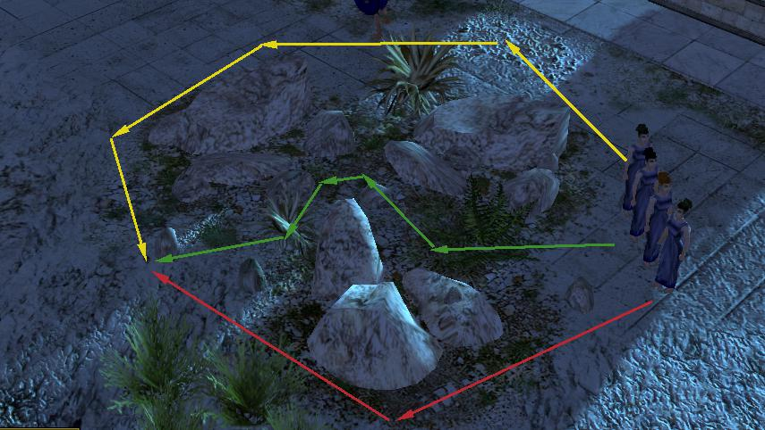

***Figure 1***

Figure 1 displays the multiple paths a unit can traverse to reach its destination. It circles around the non-rectangular obstacle and does not pass through in between.

1. **Manual**

**Problem 1**

|  |  |  |  |  |  |
| --- | --- | --- | --- | --- | --- |
| Trial | Open | Closed | Clusters | Nodes | Total |
| 1 | 18 | 12 | 2 | 10 | 145 |
| 2 | 29 | 12 | 3 | 10 | 194 |
| 3 | 21 | 10 | 3 | 8 | 138 |

***Table 1***

Table 1 is a simulation of how the algorithm works when used on a graph with non-rectangular obstacles.

1. **Proposed**
2. **Computerized**

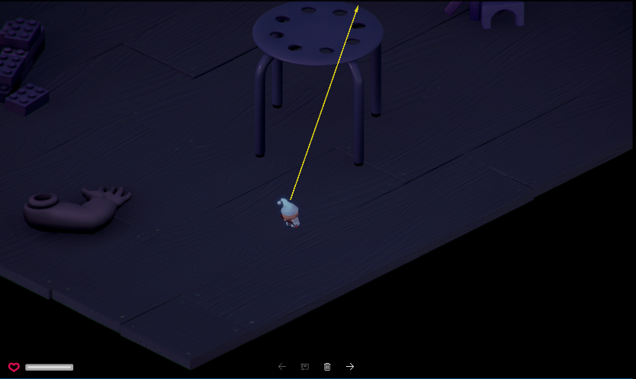

***Figure 2***

Figure 2 displays the unit passing through the area between a non-rectangular obstacle. The algorithm was enhanced using full navmesh to pass through the obstacle.

**Problem 2. Dynamic obstacles prove to be a problem for the algorithm.**

1. **Existing**
2. **Computerized**

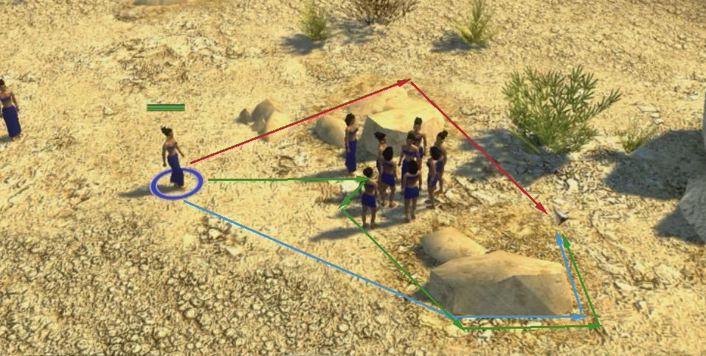

***Figure 3***

Figure 3 shows the behavior of the unit when a dynamic obstacle (different unit) is blocking its way.

1. **Manual**

**Problem 2**

|  |  |  |  |  |  |
| --- | --- | --- | --- | --- | --- |
| Trial | Open | Closed | Clusters | Nodes | Total |
| 1 | 14 | 8 | 3 | 5 | 64 |

***Table 2.1 Static***

|  |  |  |  |  |  |
| --- | --- | --- | --- | --- | --- |
| Trial | Open | Closed | Clusters | Nodes | Total |
| 1 | 19 | 10 | 3 | 9 | 128 |

***Table 2.2 Dynamic***

Table 2.1 displays the result of the algorithm’s performance when encountering static obstacles, encountering dynamic obstacles is displayed by Table 2.2

1. **Proposed**
2. **Computerized**

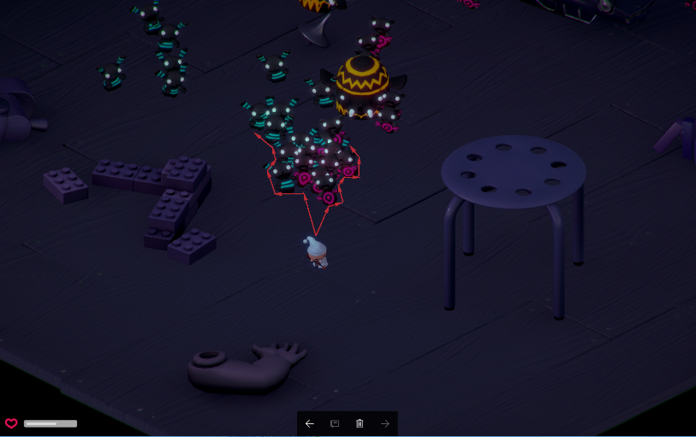

***Figure 4***

The unit shown on Figure 4 is shown as it goes at the side of the other units, these units are treated as an obstacle.

**Problem 3. Placement of transition between entrances may deviate the unit from the optimal path.**

1. **Existing**

**Problem 3**

|  |  |  |  |  |  |
| --- | --- | --- | --- | --- | --- |
| Trial | Open | Closed | Clusters | Nodes | Total |
| 1 | 14 | 12 | 3 | 13 | 194 |
| 2 | 11 | 10 | 3 | 10 | 155 |

***Table 3.1***

Table 3.1 displays the result of the algorithm as it traverses between clusters through different entrances.